OUTPUT GRAPHS USED FOR ANALYSIS AND PREDICTION

#Checking scatter plots of the Boston housing data set.

# looking at the graph,we can see there is a positive linear trend between mdev and rm

#no relation between lstat and mdev

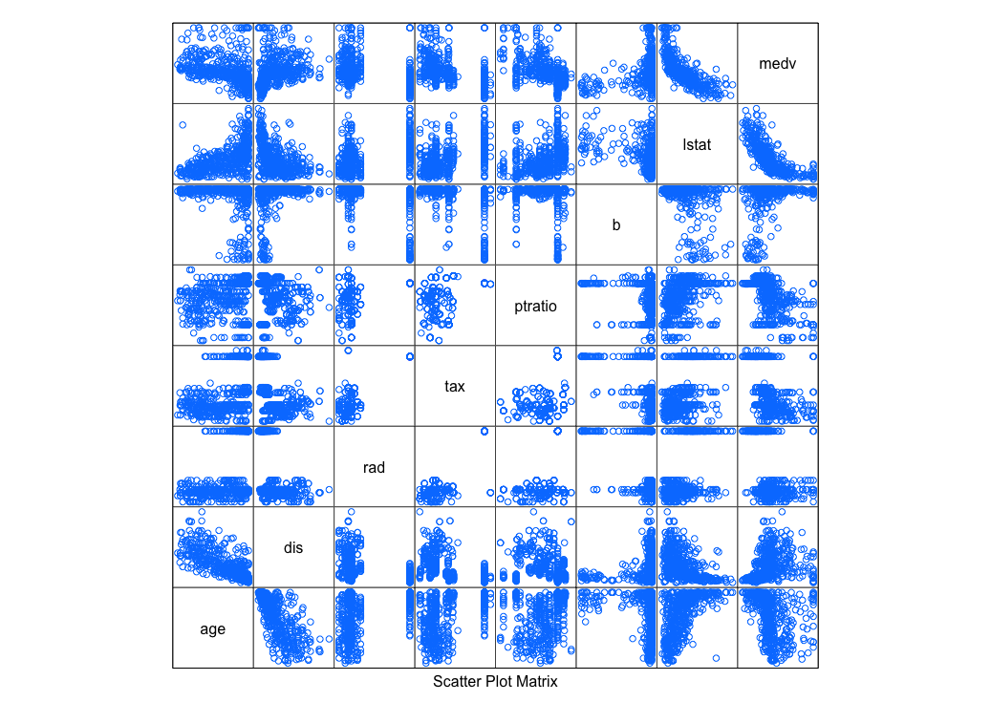

#Studying rm and medv, regression of plot

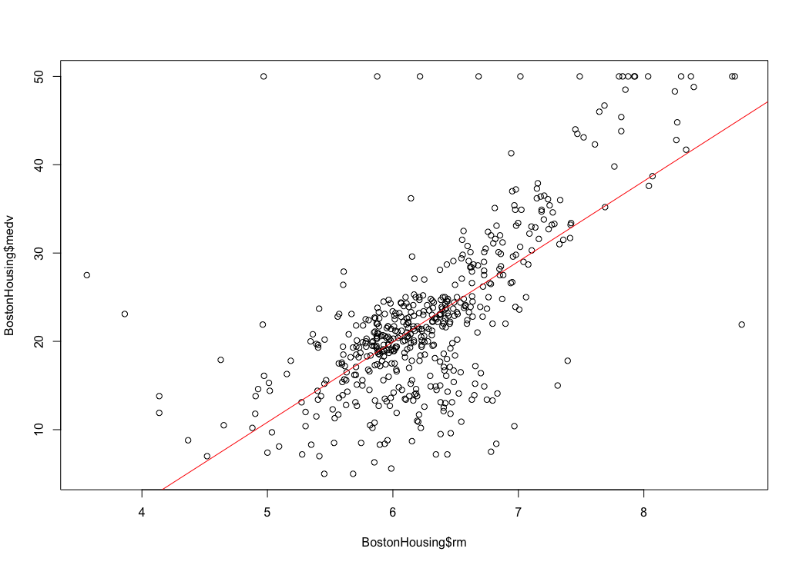

#we can use corrplot to visualize the correlation

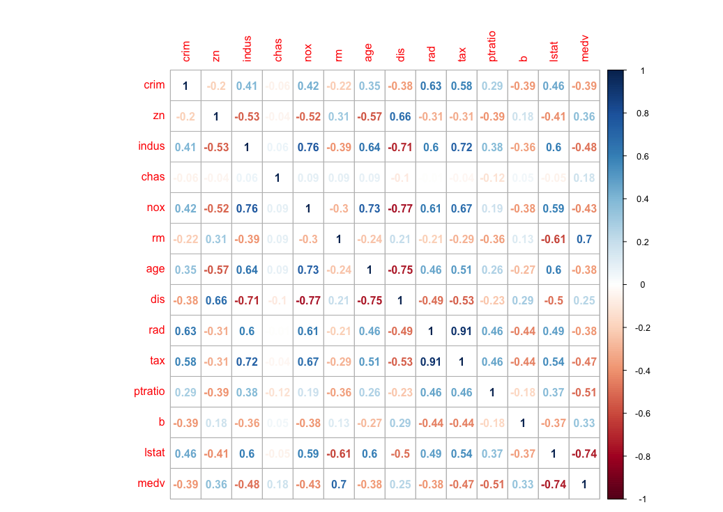

#To compare predicted values and actual values, we can use plots

